History Knowledge Organiser Year 1
Queen Elizabeth II
Need to know  - Queen Elizabeth II is a British Monarch.  - Queen Elizabeth II became queen when her father the King died.  - Lots of changes took place in the Queen’s life.  - The Queen is still important in our lives today.  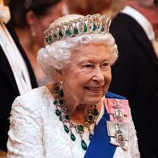  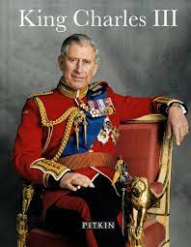  - The Queen died (2022) and King Charles III (the Queen’s Son) will be crowned King (2023).  Queen Elizabeth II | Vocabulary  recently - not long ago  now - in the present  later - in the future  a long-time ago - in the distant past  past - time that has gone by  present - now  future - the period of time that is to come  timeline - sequence events in (chronological) order  monarch - usually a king or queen part of a royal family, Head of State
Good to know  - Queen Elizabeth’s father was called King George.  - During the Queen’s life many changes have taken place including changes to technology and our homes.  - Images of the Queen can still be found on stamps, coins and post-boxes.  - The Queen was crowned in 1952 at her coronation, this was a grand occasion.  - Buckingham Palace was the London home of Queen Elizabeth.  - Monarchy is the oldest form of government in the United Kingdom. | - Sequence events and artefacts into chronological order.  - Sort artefacts into ‘then’ and ‘now’.  - Ask and answer questions related to a range of different sources.  - Use a range of sources to find out about people and what they did in the past.  - Able to represent the past in different ways (photos, stories, ICT, drama, timelines, drawing) and distinguish between fact and fiction.

