History Knowledge Organiser Year 2
Seaside Holidays Past and Present
How has a trip to the seaside changed over time?
Need to know  - Today people travel to the seaside by car or aeroplane. 100 years ago people would have travelled by horse and carriage or steam train.  - 100 years ago people would have stayed fully dressed at the beach, covering more of their bodies.  - 100 years ago children would still have enjoyed paddling in the water, eating ice cream, walking along the pier and building sandcastles.  - People still buy souvenirs to remember their trip or holiday. | Vocabulary  sources - give you information  decade - period of 10 years  century - period of 100 years  entertainment - being provided with amusement or enjoyment  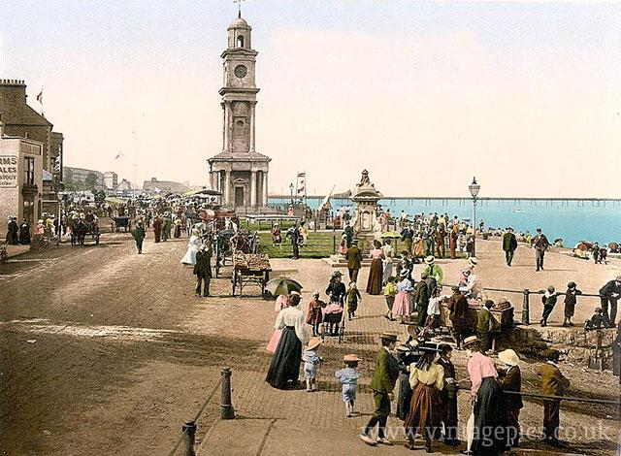  souvenir - a thing that is kept as a reminder of a person, place, or event.  Herne Bay Seafront 1900s
Good to know  - People have chosen the seaside as our location of choice for holidays and leisure time for over 100 years!  - In the past, air travel wasn't an option and so travel would be limited to the British seaside, it was believed that the seaside air was good for you.  - Modern beach holidays are very different from holidays in the past: there have been many changes, such as moving from bathing machines to beach huts.  - Bathing machines were popular in the Victorian era and helped women change into their bathing costumes. A horse would then pull it towards the sea and the women would lower themselves into it without being seen.  - Laying in the sun in your swimming attire is something else that wasn't done in the past. Instead, people would remain fully clothed and get into the sea, this was called sea-bathing.  - While some things have changed, like bathing machines and segregation, people still love eating ice cream and building sandcastles! | - Sequence events, photos and artefacts into chronological order for different periods of time.  - Use a wide range of sources and ask and answer a range of questions.  - Compare photographs of people and past events to identify differences in ways of life.  - Identify different ways in which the past is represented.  - Recognise and understand the actions of people and why events happened, developing empathy.

