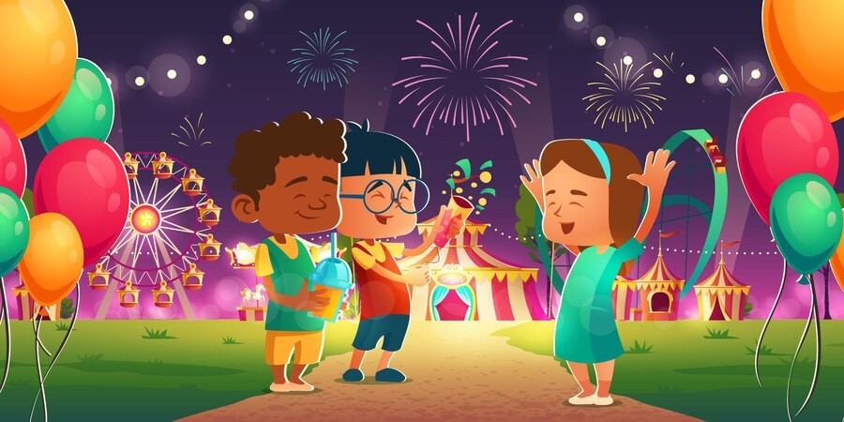

**Literacy**

Join in with songs and rhymes.

Enjoy sharing books together.

Develop play around The Gruffalo – including a Gruffalo Hunt with families.

**Personal, Social and Emotional Development**

Become confident away from main caregiver.

Play with increasing confidence on their own and with other children.

Show an awareness of the nursery rules, routines and expectations.

**Expressive Arts and Design**

Start to make marks intentionally.

Start to develop pretend play, pretending that one object represents another.

Move and dance to music.

Explore their voices and enjoy making sounds.

**Language and Communication**

Makaton Sign of the Week/Mr Tumble Sing and Sign Nursery rhymes

Nursery Rhyme of the Week

Understand simple instructions.

Listen to other people’s talk for short periods (being easily distracted is to be expected!)

**Mathematical Development**

Identify some different colours.

Take part in finger rhymes with numbers.

Complete inset puzzles.

Compare amounts saying ‘lots’, ‘more’ or ‘same.’

Develop counting-like behaviour, such as making sounds, pointing or saying some numbers in sequence.

**Physical Development**

Walk, run, jump and climb.

Sit on a push-along wheeled toy, use a scooter or ride a tricycle.

Build independently with a range of resources.

Become increasingly independent when dressing themselves e.g. putting on wellies and coat, pulling clothing up and down when using the toilet. Help may be required for buttons and zips etc.

**Understanding the World**

Explore and respond to different natural phenomena when exploring our local area during outdoor play.

Explore materials with different properties. Explore natural materials, indoors and outside relating to Autumn.

Find out about different festivals and celebrations; Bonfire Night, Remembrance Day, Diwali, Christmas. Relate back to their own experiences.

Weekly cookery session.

Books: The Gruffalo, The Snowman and the Snowdog, I love you Father Christmas, Merry Christmas Hugless Douglas, The Christmas Show, First festivals: Diwali, Peppa’s Diwali.

**2-3yr children**

**Festivals**

**Term 2 – 2023**

**6 weeks**