Core Knowledge (need to know) | Vocabulary
To throw the ball underarm.  To use a side shot throw.  To move in different ways – at speed.  To use body positioning and control to help when catching.  To discuss and apply tactics needed in dodgeball games.  To participate in dodgeball games.  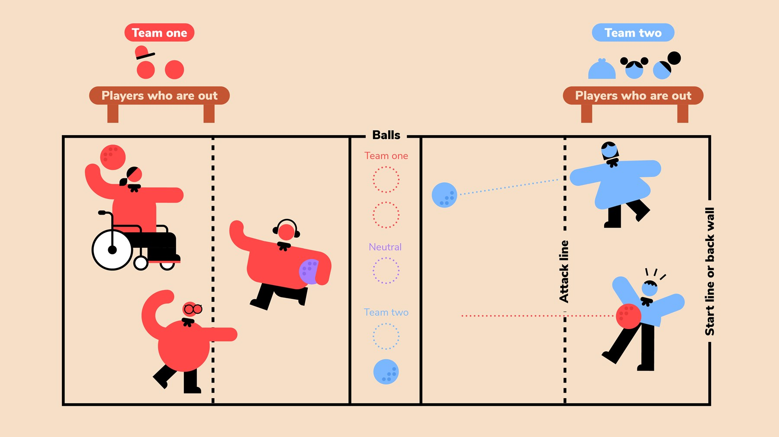  STARTING THE GAME  Game begins with players holding their balls while touching their back wall. The teams agree to start teams alternating (Team 1)Ready, (Team 2)Set, (Team 1)Go. After Go, players may begin play. If a player throws before Go, that player is Out. | Speed -  Throw -  Catch -  Dodge -  Positioning -  Underarm throw -  Side shot -  Target -  Strike -  Roll -  Good to Know  BOUNDARIES  During play, all players must remain in the arena. If you throw the ball out of the arena over the back or side walls, then you are Out.  TIME-OUTS & SUBSTITUTIONS  There are no timeouts given unless for an injury that requires play stoppage. Substitutions can occur in between games.  5-SECOND VIOLATION  In order to reduce stalling, a violation will be called if a team in the lead controls all six balls on their side of the court for more than five seconds. This also applies to teams in a tie situation.  TIMING AND WINNING A GAME  The first team to legally eliminate all opposing players will receive a point. The first team to earn two points will be the winner. A three-minute time limit has been established for each game. If neither team has been eliminated at the end of the three minutes, the team with the greater number of players remaining will receive the point.  Time in between games cannot be longer than 1 minute. Stalling will lead to an instant disqualification of the team that is not ready after 1 minute.  If a team goes into overtime, the first team to eliminate a player on the other team is the winner.

