Core Knowledge (need to know) | Vocabulary
To throw a ball at a moving target.  To use the most appropriate throwing technique for the situation.  To play catching games.  To dodge a ball by jumping and skipping.  To dodge a ball by jockeying and galloping.  To use peer evaluation to discuss strategies and tactics and apply these to your own game.  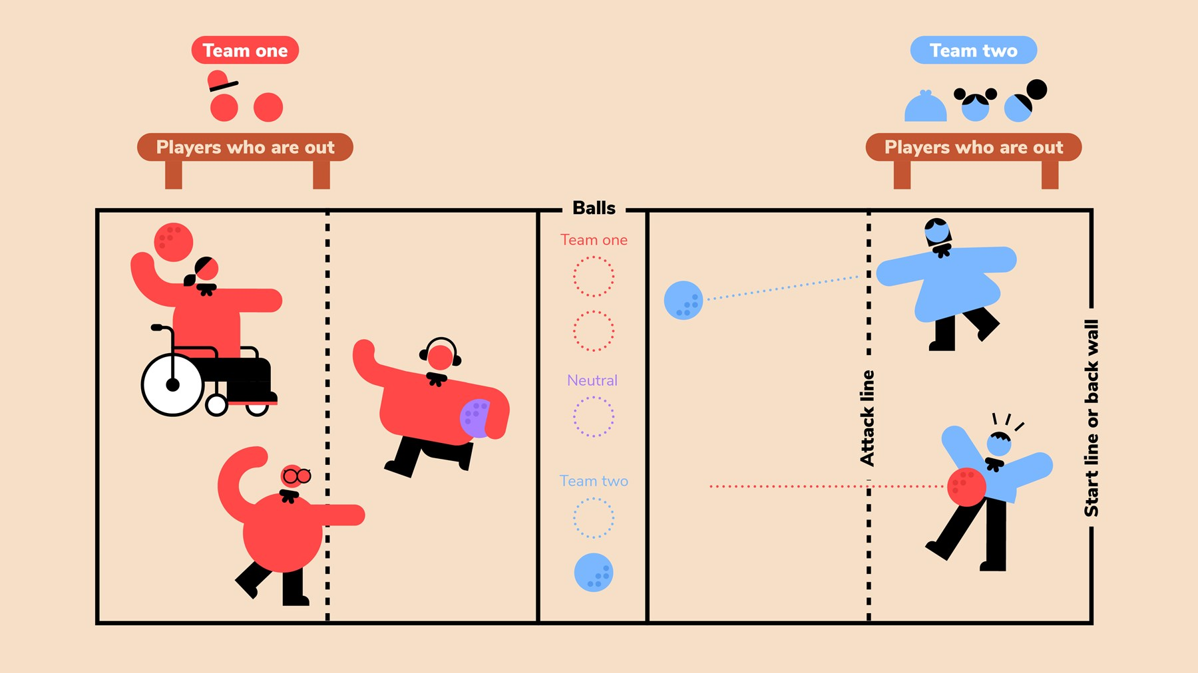  STARTING THE GAME  Game begins with players holding their balls while touching their back wall. The teams agree to start teams alternating (Team 1)Ready, (Team 2)Set, (Team 1)Go. After Go, players may begin play. If a player throws before Go, that player is Out. | Speed -  Throw -  Catch -  Dodge -  Positioning -  Underarm throw -  Side shot -  Target -  Strike -  Roll -  Good to Know  BOUNDARIES  During play, all players must remain in the arena. If you throw the ball out of the arena over the back or side walls, then you are Out.  TIME-OUTS & SUBSTITUTIONS  There are no timeouts given unless for an injury that requires play stoppage. Substitutions can occur in between games.  5-SECOND VIOLATION  In order to reduce stalling, a violation will be called if a team in the lead controls all six balls on their side of the court for more than five seconds. This also applies to teams in a tie situation.  Sacrifice Fly  An attacking player may legally cross the neutral zone to hit an opponent only if she is in the air and the ball leaves her hand before any part of her body touches the opponent’s territory. If she hits an opponent, the opponent is "out" and the attacking player remains "in."  TIMING AND WINNING A GAME  The first team to legally eliminate all opposing players will receive a point. The first team to earn two points will be the winner. A three-minute time limit has been established for each game. If neither team has been eliminated at the end of the three minutes, the team with the greater number of players remaining will receive the point.  Time in between games cannot be longer than 1 minute. Stalling will lead to an instant disqualification of the team that is not ready after 1 minute.  If a team goes into overtime, the first team to eliminate a player on the other team is the winner.

