Core Knowledge (Need to Know) | Vocabulary
To move with the ball.  To roll a ball.  To bounce a ball.  To throw a ball.  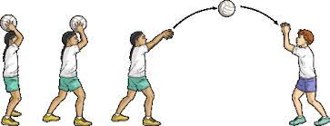  To catch a ball.  To play in games against others.  To try and rind ways to win games.  To understand how to play in a safe way.  Show good awareness of others when playing games.  Keep your eyes on your ball.  Have hands ready to catch the ball.  Good to Know  React to situations to make it difficult for opponents using simple tactics - e.g. Move to defend the goal.  Moving feet quickly can help when playing games, it can allow them to move quickly e.g. get into position to catch/stop a ball  Communicate with your partner keep together  Keep your head up to avoid collisions when moving around. | Ball The object the game is played with.  Control Holding the ball carefully.  Balance Even distribution of weight to keep upright and stable.  Throw Pushing the ball through the air with your hands.  Catch Taking the ball from the air without dropping it.  Aim To point or direct at a target  Accuracy Being precise.  Pass To give the ball to a teammate.  Roll To pass the ball along the floor.  Team You and the players on your side.  Teamwork Working with other members of your team.  Space An area where no other player is currently.

