Year 1 Unit 1: Numbers within 10 (2weeks)

Key Objectives: | Representations:
Representing numbers  - Count sets of objects within 10  - Represent numbers within 10  The primary focus of these lessons is to expose pupils to a range of different representations of number. They should see that numbers can be represented (and counted) using the concrete, pictorial and abstract. Developing this further, opportunities for discussion are provided to start making connections between the similarities and differences in representations. | 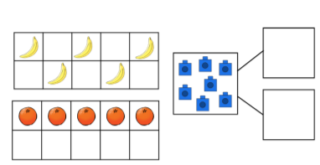
Investigating composition of numbers  - Recognise number bonds to five and six  - Recognise number bonds to seven and eight  - Recognise number bonds to nine and ten  Pupils will now begin to explore the composition of numbers from five to ten, establishing that they can be partitioned in a range of different ways. Ensuring that a range of contexts are provided will allow for a richer depth of fluency that will allow pupils to apply partitioning in later units. The language used within these lessons are key representations. Using the clear language structure alongside part-whole models helps to reinforce their understanding. | 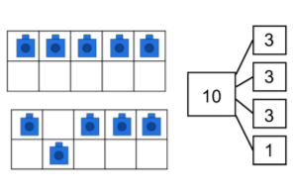
Doubling and halving  - Find double an amount up to five  - Find half of an amount within ten  Connections should be made so that pupils can understand the concept of doubling and halving and their relationship together. Crucially, the relationship of seeing that both must have two equal parts should be continually reiterated, explored and challenged. | 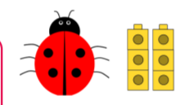
Comparing and ordering numbers  - Find one more and one less  - Compare and order two or more numbers  When finding one more and one less, pupils should use their prior knowledge of concrete and pictorial representations that have been developed in the previous lessons in the unit | 