Year 1 Unit 2: Adding & Subtracting within 10 (2weeks)

Key Objectives: | Representations:
Understanding addition  - Use the count all strategy for addition  - Use the count on strategy for addition  - Link equations to problem solving contexts  - Understand commutativity  Pupils explore two strategies for addition within 10. They begin with ‘count all’ before moving on to the more efficient ‘count on’ strategy for addition. The use of part-whole language, represented using the model, is key in developing pupils’ understanding of the relationship between numbers, manipulatives and the abstract equation and it is important that this is modelled consistently, encouraging pupils to use the language. In Lessons pupils consider a range of contexts and create problems, connecting this to part-whole models and equations. Number lines, tracks and a bead string support conceptual understanding. In Lessons, pupils apply their understanding of part-whole relationships to recognise that addition is commutative: it doesn’t matter what order you add the parts in the whole will be the same. | 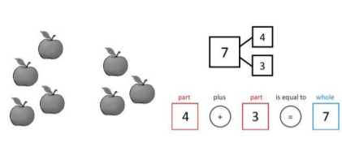
Understanding subtraction  - Subtract using partitioning  - Count back in ones to subtract  - Link equations to problem solving contexts  Pupils build on their understanding of part whole relationships to subtract using partitioning. The same models and language used in previous lessons are applied to subtraction to support pupils in making connections. In Lessons pupils use representations to subtract by counting back in ones. Lessons return to the same problem contexts as previously with pupils creating and representing their own subtraction problems using these contexts. | 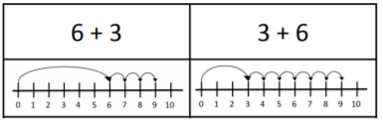
Exploring the relationship between addition and subtraction  - Recognise the relationship between addition and subtraction  - Explore problems involving addition and subtraction  In the final lessons of the unit, pupils build on their understanding of addition and subtraction. Using the models explored in earlier lessons, pupils apply their understanding of part-whole relationships to recognise the relationship between addition and subtraction. They write four possible equations for one part-whole model, explaining using the language of part and whole. Lessons provide an opportunity to problem solve using addition and subtraction strategies explored within the unit. | 