Year 1 Unit 3: Shape & Patterns (2weeks)

Key Objectives: | Representations:
Identifying 3-D shapes  - Explore, identify, describe and classify 3-D shapes  The unit begins with 3-D shapes as these are the shapes we commonly interact with: building blocks, everyday objects and items around the classroom are all three dimensional. Pupils explore a range of 3-D shapes, learning their names and, through building towers, explore the properties of these shapes. Which can roll? Which have only flat faces? While some pupils may make use of 2-D shape names to describe properties of the 3-D shapes, it is not expected but should be consistently modelled to provide opportunities for pupils to connect this understanding. Pupils explore by counting faces, edges and vertices. In Lessons pupils explore similarity and difference in grouping 3-D shapes in different ways | 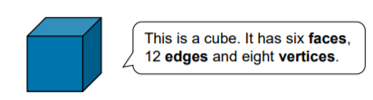
Identifying 2-D shapes  - Identify 2-D shapes  - Describe and classify 2-D shapes  In these lessons, it is important that representations shown are 2-D: using representations drawn on paper or shown on a screen. 2-D shapes are on one plane and cannot be picked up or manipulated. Consider also how using a range of representations – different colours, sizes and orientations – can deepen understanding; providing non-examples can direct pupils to think carefully about the properties of each shape. Pupils begin by identifying common 2-D shapes using images such as the Big Picture, before building their own and describing the shapes used. In Lessons pupils learn the properties of 2-D shapes and consider similarities and differences. | 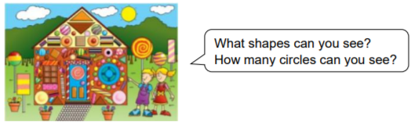
Exploring patterns  - Recognise and create repeating patterns  - Recognise and describe repeating patterns  These lessons provide a lot of opportunities for early mathematical thinking. Encourage pupils to articulate the patterns they see and make and explore what would come next if the pattern were to continue. Again, it is important to expose pupils to a range of repeating patterns using shape, colour and size. In Lessons pupils identify repeating patterns and create their own, before applying this to describing patterns and identifying missing parts in patterns. | 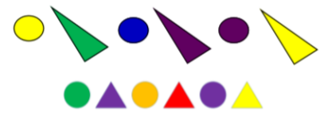
Using the language of position, direction and movement
- Use the language of position
- Use the language of position, direction and movement

The unit ends with pupils exploring the language associated with position, direction and movement beginning with a focus on positional language. Pupils should be provided with opportunities to use positional language in both 2-D and 3-D situations. Opportunities to consolidate shape and pattern understanding are provided through describing the position of shapes and patterns. In lessons the language of position and movement is introduced including left and right. Pupils should experience this linked to physical movement of themselves, their peers and programmable toys.

