Year 1 Unit 4: Numbers to 20 (2weeks)

Key Objectives: | Representations:
Counting and recognising numbers to 20  - Count from 1 to 19 and match different representations to them  - Identify numbers to 20 by first counting to 10 and then counting on  Pupils build on their understanding of numbers to 10. They count and name the tricky ‘teen’ numbers. They need encouragement to develop a systematic approach to counting, progressing from ‘count all’ to ‘counting on from ten’. Pupils should be supported to see numbers between 10 and 20 as ‘ten and a bit more’ by making groups of ten with cubes, beads and ten frames as well as circling groups of ten in pictorial representations. | 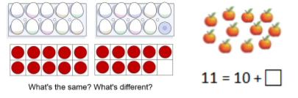
Comparing and ordering numbers to 20  - Position numbers to 20 on a number line  - Compare numbers within 20  - Compare and order three or more numbers within 20  Pupils use concrete, pictorial and abstract representations to compare numbers. Using cubes, number lines, ten frames and bead strings, they focus on the composition of ‘teen’ numbers, building a foundation for understanding place value. They develop the vocabulary for comparing, such as, before, after, more, less, equal, greater than, fewer, smaller, smallest, greatest. | 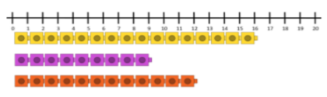
Identifying one more and one less and using the appropriate language to compare  - Say one more or one less than a number within 20  Pupils use cubes, number lines and bead strings to develop fluency and use counting on to 20 and back and their knowledge of before and after. Pupils apply their learning around ‘ten and a bit more’ from prior lessons when reasoning why numbers are one more or one less than others. Pupils use the previously learnt approach of ‘counting on from ten’ when comparing numbers. Pupils need encouragement to see the patterns that ‘one more is added each time’. | 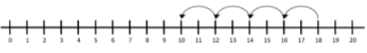  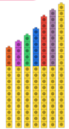
Identifying number patterns
- Identify, complete and continue number patterns
- Understand odd and even numbers
Pupils deepen their understanding of patterns in our number system and explore similarities and differences. Pupils need modelling to generalise that in increasing patterns, the numbers become greater in value and in decreasing patterns, the numbers become smaller in value. Use of concrete representations emphasise these patterns, such as arrows on a number line and towers of cubes.
Doubling and halving numbers
- Double and halve numbers within 20

Pupils use concrete representations and one to one correspondence to double and halve sets of objects. They are taught together to link doubling and halving as inverse operations. A real-life context of Buy One Get One Free supports children to begin to get a sense of the concepts which will be revisited later in the year.

