Year 1 Unit 5: Addition and subtraction within 20 (2weeks)

Key Objectives: | Representations:
Addition and subtraction using counting on and back
- Add by counting on
- Subtract by counting back

Pupils are introduced to the ‘change’ additive structure of augmentation (increasing) and reduction (decreasing) for addition and subtraction using a story setting. They will build on their idea of ‘adding on’ or ‘taking away’ one number to or from another and should be encouraged to make links between the inverse relationship of addition and subtraction. The ‘first, then, now’ pictorial model for their change stories supports reasoning and provides linguistic scaffolding to write abstract equations. Conceptual understanding is further developed using number lines and a number track to count on or back, supporting pupils to create a mental image of the process which they can apply to later lessons.
Addition and subtraction using known facts  - Add a 1-digit number to a teens number by using known facts  - Subtract a 1-digit number from a teens number by using known facts  Pupils continue to use ‘first, then, now’ maths stories alongside cubes to understand and model scenarios before writing and solving related equations. Encourage pupils to develop efficient strategies for addition and subtraction, focusing on reasoning how to use known bonds within 10 to derive bonds within 20 | 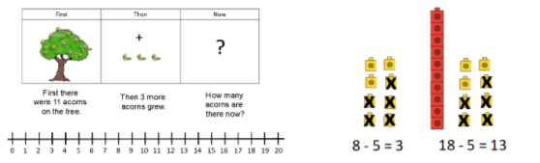
Addition and subtraction using the ‘Make ten’ strategy  - Use the ‘Make ten’ strategy to add two 1-digit numbers  - Use the ‘Make ten’ strategy to subtract a 1-digit number from a teens number  Pupils will explore adding two 1-digit numbers where the total is a teen number by using the ‘Make ten’ strategy to bridge through ten before applying the ‘Make ten’ strategy to subtract a 1-digit number from a teens number. Watch the video to ensure you are confident in modelling this for pupils. Throughout, pupils apply their knowledge of number bonds and partitioning within ten; many pupils will still be developing these skills and therefore the use of concrete and pictorial representations should be modelled to develop their conceptual understanding. | 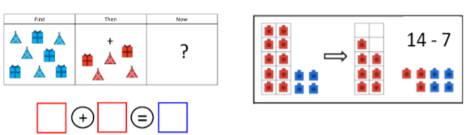
Application of addition and subtraction strategies  - Apply mathematical models and strategies for addition and subtraction  Through a real-life situation of passengers getting on and off a bus, pupils will learn to create mathematical models to make sense of mathematical problems. They use concrete representations as well as pictorial and abstract markings. This exploratory activity will be an opportunity to build on and apply the strategies learnt in this unit. It could be used as an opportunity to assess which pupils are beginning to use number bonds. | 