Year 1 Unit 6: Time (2weeks)

Key Objectives: | Representations:
Using language and units of time  - Know and order the months of the year  - Sequence events in chronological order  - Understand that time can be measured in minutes and seconds  Pupils begin by learning and ordering the months of the year, making use of ordinal numbers (January is first, February is second) and positional language (February comes before March and after January) to develop an understanding of the order. Through discussion, they recognise the cyclical nature of the months. Chanting months of the year beginning at different starting points is a good way to secure this understanding. In Lessons, the chronological language is applied to sequencing events across a day, developing an understanding of social time. Pupils are introduced to minutes and seconds as units for measuring time. Pupils learn that a minute is sixty seconds in length and discuss activities which may take more/less than one minute. This is an opportunity to explore colloquial language use such as ‘wait a second’. Through practical activities, pupils gain a sense of how long a minute, and duration of 20 seconds is. | 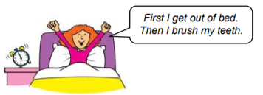
Reading a clock: o’clock and half past  - Read and write the time: o’clock  - Read the time: half past  - Read the time: o’clock and half past  Pupils are introduced to an analogue clock face, preferably using a geared clock. Through careful modelling and opportunities to practice and repeat, pupils recognise the minute hand (the longer hand) and the hour hand (the shorter hand) and recognise the position of the hands to show a specific hour, using o’clock. Through comparison of clocks in Lesson 5 they identify the position of the hands showing half past and use the phrase ‘halfway between’ to recognise the hour. Again, pupils should have multiple opportunities to see and represent different times and further opportunities for this are provided. | 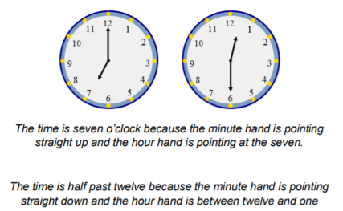
Applying understanding of o’clock and half past  - Write the time in words: o’clock and half past  - Explore adding on hours and half hours  Pupils have opportunities to connect the analogue representation of time with sequencing and writing time considering what activities are done at different times of the day. Lessons provide opportunities for pupils to add hours or half hours to times through playing a game, consolidating the skills developed in earlier lessons. | 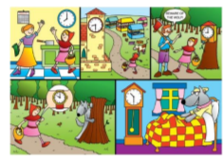
Exploring position, direction and movement  - Use the language of position, direction and movement  Pupils have explored positional and directional language including right and left in a previous unit and are now introduced to half turns and whole turns before considering quarter turns. Multiple opportunities should be provided for pupils to practically turn to explore this movement as well as attaching this movement to the hands of a clock, using clockwise and anti-clockwise. | 