Year 1 Unit 7: Exploring calculation strategies within 20 (2weeks)

Key Objectives: | Representations:
Deriving related facts  - Use number bonds to derive facts  The first strategy explored in this unit is using known number bonds to derive addition and subtraction facts. Encourage pupils to focus on reasoning how to use known bonds within 10 to derive bonds within 20. Opportunities should be provided for pupils to explain related part-whole models and explore how they can use known facts to calculate using numbers greater than 10. | 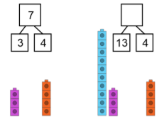
Using doubles
- Use doubles to calculate near doubles

Pupils begin by consolidating their understanding of doubles and teacher assessment should be used to ascertain how much time should be dedicated to this. The learning then extends to making use of known doubles to calculate near doubles: how can I use double 3 to calculate 3 + 4? Concrete manipulatives should be used when modelling and in pupil work to emphasise the use of the double fact to calculate.
Using ‘make ten’  - Represent the ‘make ten’ strategy on a bead string  Pupils revisit the ‘make ten’ strategy from an earlier unit, deepening understanding through the introduction of representing this on a bead string. Throughout, pupils apply their knowledge of number bonds and partitioning within ten; many pupils will still be developing these skills and therefore the use of concrete and pictorial representations should be modelled to develop their conceptual understanding. | 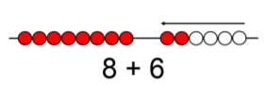
Understanding equality  - Recognise the equals sign = as balance  Pupils learn the importance of the equals symbol as a sign of equivalence or balance through applying known number bond knowledge e.g. recognising that 4 + 1 is the same as 3 + 2. Part-whole models are used to represent equations alongside cube ‘trains’ to clearly show equal length. These representations are connected to abstract equations e.g. 4 + 1 = 3 + 2. Pupils should also have opportunities to consider non-examples. Pupils then explore equations with missing parts, applying the representations developed to find missing parts and balance the calculation. | 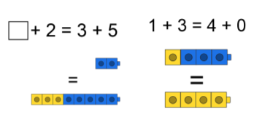
Making choices
- Choose a strategy based on numbers in the calculation

Pupils apply the range of strategies explored within the unit to begin to develop flexibility in addition. It is important that pupils understand there is no right or wrong way to approach a calculation: indeed, at this stage some pupils may be less confident with certain strategies. The focus should be on pupils playing with different strategies and teacher modelling of reasoning in strategy selection.

