Year 2 Unit 1: Numbers within 100 (2weeks)

Key Objectives: | Representations:
Identifying tens and ones in 2-digit numbers
- Explore 2-digit numbers by grouping in tens
- Identify tens and ones in a 2-digit number

Using the Big Picture to contextualise place value, pupils organise fruit into bags of ten and leftover ones. Providing pupils with practical experiences of organising everyday objects into groups of ten helps them to make sense of our abstract number system (place value). These experiences are essential in developing conceptual understanding before working with bead strings and Dienes on a place value chart.
Partitioning 2-digit numbers into different combinations  - Partition 2-digit numbers  - Partition 2-digit numbers  Pupils use part-whole models to partition numbers into tens and ones. Make connections across pictorial (fruit), concrete (Dienes and bead strings) and abstract (numerals) representations. Links to commutativity can also be made – changing the order the parts are added does not affect the value of the whole. Exposing pupils to non-standard equations (34 = 30 + 4) can deepen their understanding. Lesson 4 applies this learning to non-canonical partitioning (34 = 24 + 10). | 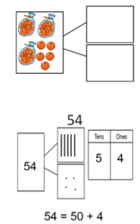
Problem solving with place value
- Represent 2-digit numbers

Pupils apply their learning so far to represent a range of 2-digit numbers on a number line as well as identifying mystery numbers from clues. Encourage pupils to go beyond simply finding an answer for each clue - engage in mathematical thinking by using a range of representations to find all possibilities.
Representing 2-digit numbers with words  - Read and write numbers to 100 in words  Pupils explore patterns in writing 2-digit numbers in words. Make connections to corresponding abstract representations (numerals) and to previous learning in this unit on partitioning using part-whole models. Pupils might find teen numbers challenging. They may apply their knowledge of place value (tens then ones) and write ‘ten three’ instead of ‘thirteen’. Plan to spend time exploring this in the Develop Learning | 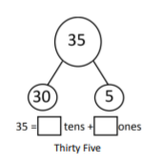
Comparing and ordering numbers to 100  - Compare numbers to 100  - Order numbers to 100  - Explore number patterns  Pupils apply their learning from lessons throughout this unit to compare numbers to 100, with < and > symbols introduced. Pupils use familiar representations such as Dienes and bead strings to support them in coming to generalisations such as ‘when the tens values are the same, the value of the ones is compared’ and ‘when the tens values are different the value of the tens is compared’. Pupils can apply these generalisations when ordering multiple numbers. Lessons focus on counting forwards and backwards in threes, applying knowledge of ordering numbers. Pupils engage in mathematical thinking when predicting and justifying the value of numbers in sequences. | 