Year 2 Unit 3: Addition and subtraction word problems (2weeks)

Key Objectives: | Representations:
Moving from part-whole models to bar models  - Represent information as a bar model  Pupils use the familiar representation of cubes within a part-whole model to represent known and unknown values in word problems involving ‘combination and partitioning’ additive structures. Encourage pupils to apply the mental strategies from Unit 2 to solve the word problems. This learning is extended to explore another pair of additive structures, ‘augmentation and reduction’ | 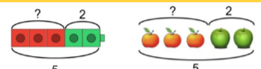
Creating and labelling bar models  - Create and label bar models  - Sketch bar models  Pupils apply their learning of the additive structures from previous lessons, but now place cubes into ‘segmented’ bar model frames. Working in these frames supports pupils to begin visualising the ‘bars’ of bar models. This learning is developed in lesson 4 where numbers beyond 20 are introduced. Frames become more ‘abstract’ and non-segmented. Use this opportunity to emphasise how labelling each bar to represent its value is more efficient than segmenting. Once pupils are secure working with bar model frames, lessons provide the opportunity to sketch bar models ‘freehand’. | 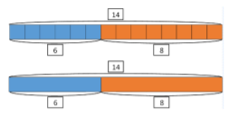
Exploring comparison additive structures  - Represent comparative word problems using bar models  Comparison structures and their word problems are known to be the most challenging for pupils to interpret. Compared to ‘part-whole’ bar models experienced with the previous additive structures explored in this unit, comparative bar models look different. With this in mind, this lesson sequence has been designed to return back to building bar models concretely to deepen understanding. | 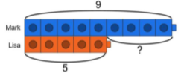
Developing understanding of additive structures
- Sketch bar models to represent word problems
- Identify suitable bar models to represent problems

In both lessons, pair work encourages dialogue around interpreting word problems. These have been deliberately designed to include the same numbers but different additive structures. In order to identify the calculation required, pupils continue to ask themselves ‘what do we know? What do we not know?’ to interpret the word problem and represent the known and unknown values using bar models. Mathematical thinking is further promoted as pupils sort and classify word problems, pupils match bar models to word problems.

