Year 2 Unit 4: Measuring Length (2weeks)

Key Objectives: | Representations:
Comparing, estimating and measuring length
- Compare non-standard units and standard units
- Estimate and measure lengths in metres

Pupils need opportunities to use a variety of non-standard units to measure classroom objects to develop accuracy and the language for measuring. By promoting comparison and discussion on the differences in pupil answers, they begin to recognise the need for standard units. The metre stick is established as a standard unit by modelling correct use and alignment for measuring from zero. Exaggerating the possible errors will promote the importance of accuracy. By comparing lengths to a metre they develop the image and understanding of the length of 1 metre as a reference point.
Measuring and estimating length in centimetres
- Measure length in centimetres
- Estimate and measure length in centimetres

Pupils will gain conceptual understanding of length through hands-on experience of measuring in centimetres with Dienes ones blocks and a ruler. Teacher modelling and pupils comparing their answers will establish the importance of aligning the ruler close and parallel to the line and starting from zero. Through measuring, comparing and ordering objects measured in centimetres, pupils will explore the principle of transitivity that if A>B and B>C then A>C and develop a sense of estimation of length.
Exploring and measuring length in different contexts  - Measure curved and straight lines  - Investigate the length of certain body parts  In these lessons pupils use relevant contexts for measuring straight and curved lines in 2D shapes and exploring the relationship between lengths of different body parts. Through first-hand experience they practice and improve their coordination and measuring skills using centimetres, rulers, string and measuring tapes. It is crucial to build in habits of estimation, comparison and checking for accuracy through teacher modelling and paired talk. Develop language and communication through encouragement and scaffolding to reflect and talk so that they make connections and comparisons between different measures and representations | 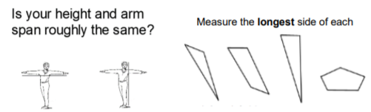
Drawing specified lengths
- Draw lines with specified lengths

Through clear modelling, pupils develop their coordination skills to use a ruler to draw lines starting at zero and finishing at the end point. Good habits of checking for accuracy are established by realigning the ruler to check. Pupils also develop mathematical thinking and the vocabulary to compare lengths to solve word problems through use of bar models and bead strings.
Solving word problems  - Apply knowledge of length when problem solving  Pupils develop conceptual understanding by using bar models to solve part-whole and comparison word problems in the context of length. They draw upon their use of estimation, mental strategies and checking of answers using the inverse to solve one step and two-step problems. | 