Year 2 Unit 5: Graphs (1week)

Key Objectives: | Representations:
Representing data using a table, pictogram and block diagram  - Represent and interpret data using a pictogram and table  - Represent and interpret data using a block diagram and table  Pupils develop an understanding of what is meant by data (information) and begin to gather data first from each other (e.g. collecting data about eye colour), then using the alien resource sheet. Pupils organise their data into a pictogram before interpreting their data and recording in a table. In Lesson 2, pupils move on to organising data in a block diagram and build on their conceptual understanding of data through further discussion and interpretation of the data. | 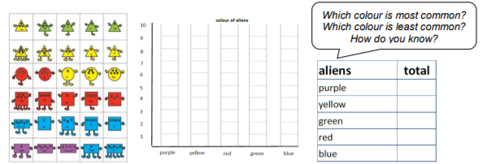
Representing data using a tally chart, pictogram and block diagram  - Represent and interpret data using a tally chart and scaled pictogram  - Represent and interpret data using a tally chart and scaled block diagram  Pupils are introduced to tallies as another way of recording data: ensure pupils have opportunity to make sense of the structure of tallies with the diagonal mark representing the fifth item and the purpose of tallies to support them to count efficiently in groups of five. They will transfer data collected using a tally chart into a scaled pictogram and then a block diagram. Again, spend time discussing and interpreting the data collected, drawing attention to the scale used in each representation. | 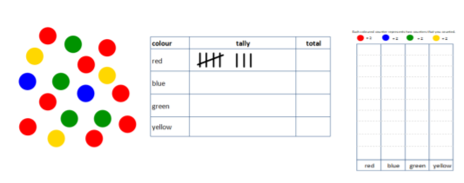
Interpreting data  - Interpret data from scaled pictograms and block diagrams  Pupils develop an understanding of the purpose of data representations through describing the information shown by various pictograms and block diagrams. Mathematical thinking is developed by asking them to look at two data representations and sort questions according to what can and cannot be answered using each representation. Throughout the lesson pupils will be exposed to different scales that will require them to apply strategies for counting in 2s, 5s and 10s. | 