Year 2 Unit 7: Time (2weeks)

Key Objectives: | Representations:
Understanding units of time
- Know that there are 24 hours in one day
- Know that there are 60 minutes in one hour

Pupils begin by applying their understanding of personal and social time to recognise that one whole day consists of 24 hours. This is attached to telling the time on an analogue clock, identifying that each hour is represented twice in 24 hours. Providing opportunities to relate these times to social and personal time (what you may be doing at 3 in the afternoon or 3 in the morning) helps pupils gain a sense of this. In Lessons, pupils connect their understanding of minutes to that of an hour and learn that there are 60 minutes in one hour. Take time to carefully connect this to a clock face, identifying that one rotation of the minute hand represents 60 minutes, whereas the hour hand only moves one interval. When thinking about minutes, use careful representations to identify that the larger intervals on a clock scale represent five minutes. Pupils then consider everyday activities and whether these could be reasonably measured in minutes or hours.
Reading an analogue clock  - Identify quarter past on an analogue clock  - Identify quarter to on an analogue clock  - Read the time on the clock to the nearest five minutes (past)  - Read the time on the clock to the nearest five minutes (to)  - Sequence daily events  Pupils consolidate their understanding of o’clock and half past before learning quarter past, followed by quarter to. They connect the position of the minute hand with fraction understanding: the minute hand is a quarter of the way around the scale. Multiple opportunities should be provided for pupils to see and hear this as well as represent it for themselves. Through comparison of these times they consider what is the same and what is different and make connections between quarter past and the number of minutes this is equivalent to. In Lessons 5 and 6 reading a clock is extended to reading to the nearest five minutes, drawing on their understanding from previous lessons. It is important that pupils develop a deep understanding of the dual nature of the scale, and repeated use of clear sentence stems can support this. In lessons, pupils apply their understanding of reading time to the nearest five minutes to sequence events across a day. | 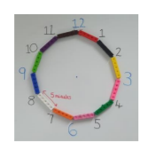  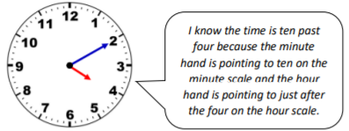
Calculating of reading a clock
- Calculate durations of time in minutes
- Calculate durations of time in hours and minutes

In the final lessons of the unit, pupils apply their understanding of reading analogue clocks to calculating time durations, first in minutes and then in hours and minutes. Modelling on an analogue clock and counting in five minute intervals (forward and back) is key to developing conceptual understanding. In lessons an empty number line is used alongside an analogue clock to record the steps used to calculate the time duration. When using this representation, careful modelling by ‘thinking aloud’ the steps and the connection to the analogue clock is key to pupils’ understanding.

