Year 3 Unit 1: Number sense (3weeks)

Key Objectives: | Representations:
Developing number sense  - Exploring number sense  - Derive new facts from known facts  The year starts with opportunities for pupils to show what they know about numbers and number facts. You should celebrate and explore their growing number sense which will be used to develop increased flexibility in calculating throughout this unit and beyond. Explore multiple representations of number and related facts that pupils are familiar with and use information gathered from these experiences to inform content of Maths Meetings, transitions and consolidation lessons. | 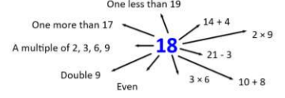
Understanding our number system  - Explain that number names do not follow regular patterns  - Say the value of each digit within 2-digit numbers  - Compare and order numbers within 100  To gain a greater understanding of our number system, pupils explore the language of numbers and the patterns within the digits. Pupils can then make connections between this and the value of digits in 2-digit numbers before applying their understanding of place value to ordering numbers | 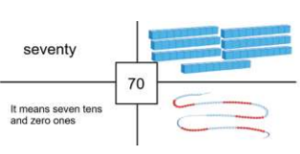
Investigating and using number bonds  - Investigate number bonds to 20  - Apply number bonds up to 10 to calculate without regrouping  - Apply number bonds up to 20 to calculate with regrouping  Using part-whole language and a variety of representations (including bar models) pupils explore number bonds to 20. Time should be dedicated to representing, understanding and becoming fluent with these facts as they underpin calculation strategies. When calculating in lessons, pupils should have opportunity to compare different strategies such as the “make ten” strategy with using the “number bonds to 20” thinking about which they think is more efficient. | 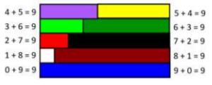
Using addition and subtraction strategies  - Round and adjust to add/subtract with near multiples  - Round and adjust to add with near doubles  - Find the difference by adding on  Lessons explore calculation strategies that pupils have been introduced to in previous years. The focus should be on discussing and reasoning about when each strategy might be used and which strategy might be the most efficient depending on the numbers involved. | 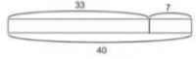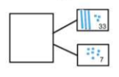
Solving money problems  - Solve money problems using mental calculating strategies  The context of money is used to apply the calculation strategies reviewed across this unit. This can be used as an opportunity to build bar models to represent problems before selecting efficient strategies. | 