Year 3 Unit 2: Place Value (2weeks)

Key Objectives: | Representations:
Understanding number  - Recognise place value of each digit in a 3-digit number  - Partition numbers  - Order and compare numbers  Dienes blocks are used to support pupils in developing a secure understanding of the value of each digit in 3-digit numbers. Pupils should be given opportunities to explore and play with numbers and be encouraged to partition numbers in different ways using Dienes equipment (see video above). Pupils can then apply their understanding of place value to ordering and comparing numbers. | 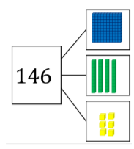  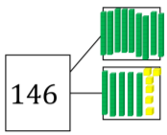
Identifying 10 and 100 more or less  - Add and subtract 10 and 100 to/from a 3-digit number  Using their understanding of place value, pupils calculate 10 or 100 more or less. Pupils should continue to use Dienes blocks so that they can explore how adding and subtracting 10 or 100 changes the magnitude of the number. | 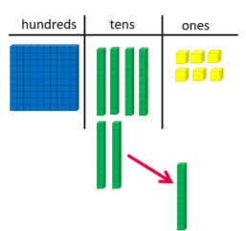
Rounding numbers  - Round numbers to the nearest multiple of ten  - Round numbers to the nearest multiple of 100  Pupils use number lines and bead strings to support their understanding of rounding to the nearest multiple of ten. Pupils have the opportunity to fully explore rounding to the nearest multiple of ten before moving on to rounding to the nearest multiple of 100. One way to do this is to explore all possible numbers that could be rounded to a particular multiple. | 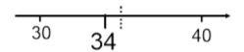
Solving problems using place value understanding
- Apply place value knowledge to problems

Pupils solve place value problems such as finding the smallest/largest 3-digit number made from a selection of digit cards. Constraints can be added such as finding the smallest odd number, largest multiple of 5 and so on. Pupils explore a range of problems where there is more than one possible answer. Pupils are asked if they can find all the possibilities for each problem and asked to explain how they know they have found all the possibilities.

