Year 3 Unit 3: Graphs (1week)

Key Objectives: | Representations:
Interpreting and creating pictograms  - Read and interpret pictograms  - Construct a pictogram  Pupils begin by exploring pictograms where the symbol represents a value greater than one. Pupils interpret the pictograms using whole symbols before moving on to consider the value of part of a symbol. They then consider the commonality between the numerical values in order to decide on an appropriate scale to use when presenting data as a pictogram | 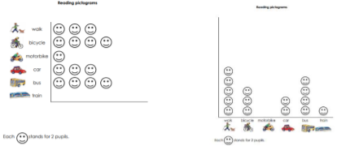
Reading and interpreting scaled bar charts  - Read and interpret bar charts  Pupils interpret scaled bar charts where the y-axis increases in increments of two and compare these with scaled bar charts where the increments are in fives and tens. Pupils then move on to explore and interpret bars where values sit between the marked increments on the scale. | 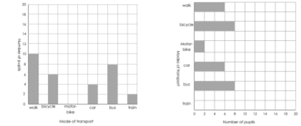
Collecting and presenting data  - Collect and present data using tallies, tables and graphs  - Interpret and present data in pictograms and scaled bar charts  Pupils use tally charts as a way of recording collected data before choosing the type of graph to present the information, explaining and justifying their choice. Pupils make connections between the values in a data set and their knowledge of multiples to decide on an appropriate scale. They then complete missing information on tallies and bar charts, interpreting the data shown and identifying questions which cannot be answered using the information. | 