Year 3 Unit 4: Addition & Subtraction (3weeks)

Key Objectives: | Representations:
Developing mental strategies for addition and subtraction  - Add or subtract single digit numbers to or from a 3-digit number  - Adding 3-digit number and multiple of 10  - Subtracting a multiple of 10 from a 3-digit number  - Add or subtract a multiple of 100 to and from a 3-digit number  - Adding or subtracting two 3-digit numbers (no regrouping)  Pupils use bead strings, Dienes and part-whole models to enable them to build upon their existing understanding of number bonds and place value, applying this in order to support addition and subtraction, where regrouping is required. Encourage pupils to use existing known facts to allow more efficient calculating. Connections should be made between the lessons and the similarities/differences in strategies. | 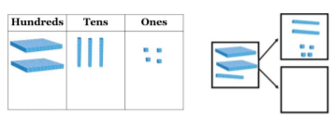
Calculating with column addition  - Applying rounding for estimating  - Adding two 3-digit numbers (regrouping in one column)  - Adding two 3-digit numbers (regrouping in multiple columns)  Understanding of rounding numbers is applied in the context of selecting calculations to estimate. Discussion can be held around the different options for estimating and if the actual result will be greater or less than the estimate. Understanding the method of column addition is supported with Dienes blocks, using them to explain each step. Time is spent exploring and correcting common errors or potential misconceptions. | 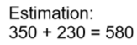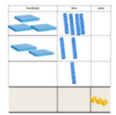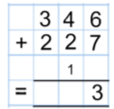
Calculating with column subtraction  - 3-digit subtraction (regrouping tens to ones)  - 3-digit subtraction (regrouping hundreds to tens)  - 3-digit subtraction (regrouping in multiple columns)  Dienes continue to be a key resource as the focus changes to column subtraction. Time is dedicated to developing secure understanding of when regrouping is required and beginning to do this with increased confidence. Common errors are highlighted and used to deepen understanding of how the method works and links with existing understanding of addition and subtraction. | 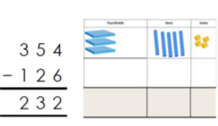
Applying understanding to solve problems  - Solve word problems using addition and subtraction skills  - Word problems with tricky unknown values  Pupils then use addition and subtraction in order to help them to engage with and solve a range of word problems. To support problem solving, bar models used as tools for identifying a strategy to solve a problem. The power of the bar model is in building it as a way to explore the structure of the problem and time should be spent discussing and drawing these. Pupils are also exposed to non-standard word problems to demonstrate the value of the use of bar models where language is counter-intuitive to the operation required. | 