Year 3 Unit 5: Length & Perimeter (2weeks)

Key Objectives: | Representations:
Working with centimetres and millimetres  - Measure using cm or mm  - Measure and draw using mixed cm and mm  - Estimate length by comparing; measure to compare  Pupils are introduced to millimetres and their relationship with centimetres. They learn skills to measure accurately, first in centimetres or millimetres, then using mixed units in the following lesson. Pupils develop a sense of 1 cm through use of Dienes equipment, using this to estimate length before checking using a ruler. Pupils should estimate and measure a range of objects including strips of paper and classroom items. | 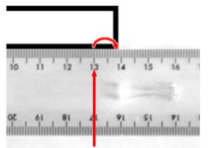
Calculating perimeter in centimetres and millimetres  - Calculate the perimeter of 2-D shapes in cm or mm  - Calculate the perimeter of 2-D shapes in cm and mm  Pupils are introduced to the concept of perimeter as the distance around the exterior of a 2-D shape. Pupils explore different strategies for calculating perimeter, first in one unit and then in mixed units, drawing on known additive and multiplicative strategies. Pupils recognise that different rectangles can have the same perimeter through constructing a variety of rectangles with a set perimeter, making conjectures and working systematically. | 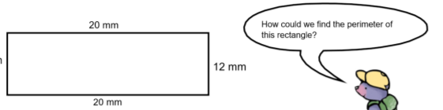
Working with centimetres and metres  - Measure and compare length in cm and m  - Calculate perimeter in m and cm  Re-introduce a metre, making connections with centimetres and millimetres, developing pupils’ understanding of the relationship between these. Pupils should be encouraged to apply strategies from working with cm and mm to working with metres and centimetres. Pupils first use measuring equipment to estimate, measure and compare lengths greater than one metre. They then apply skills developed in an earlier lesson to calculating the perimeter of shapes using metres and centimetres. | 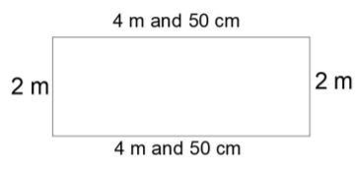
Solving problems involving length
- Solve problems using different units of measure

Pupils work collaboratively in groups to solve a series of clues and problems, using units of measure encountered in the unit.

