Year 3 Unit 7: Deriving multiplication and division facts (3weeks)

Key Objectives: | Representations:
Comparing multiplication structures  - Compare multiplication structures  Multiplication can be seen as ‘equal parts’ or as ‘times greater’. Pupils explore word problems, build bar models to represent them and think about how to interpret the calculations used to solve them | 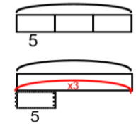
Multiplying and dividing using place value
- Multiply by 10 and 100
- Link place value with multiplication
- Divide by 10 and 100 L5 Multiplying and dividing by 10 and 100

Pupils use Dienes, place value charts and counters to explore multiplication and division by 10 and 100. Explore that when moving to the left, digits have a value that is ten time greater and moving to the right, digits have a value that is ten times less.
Applying learning  - Explore division strategies  - Derived facts  Pupils explore how dividing by grouping gives the same result as dividing using place value. Apply learning to derive new facts. | 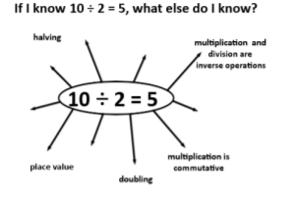
Multiplying and dividing 2-digit numbers  - Multiply a 2-digit number (no regrouping)  - Multiply a 2-digit number (with regrouping)  - Divide a 2-digit number (no regrouping)  Pupils multiply and divide 2-digit numbers by partitioning. Multiple models are used to support the development of understanding and the suggested route begins with using arrays of counters, moving to using Dienes, followed by use of place value counters. | 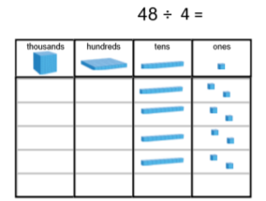
Solving word problems  - Solve multiplication and division word problems  - Solve word problems involving the four operations  Pupils apply the understanding developed within this unit by solving word problems. | 