Year 4 Unit 1: Reasoning with 4-digit numbers (2weeks)

Key Objectives: | Representations:
Understanding our number system  - Recognise the place value of each digit in a 4-digit number  - Order and compare numbers beyond 1000  Using Dienes and place value counters on a place value chart, pupils recognise how the position of a digit affects its value. Pupils apply this knowledge to order and compare numbers, learning to compare digits with the greatest value first. | 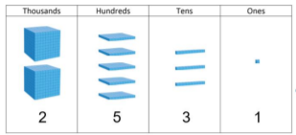
Identifying 10, 100, 1000 more or less  - Find 10, 100, 1000 more or less than a given number  This lesson applies learning, including representations, to develop a sense of how numbers relate to each other. Identifying 1, 10, 100 and 1000 more or less than a number can focus attention on which digits change and which stay the same. This is an opportunity to make connections with regrouping and ensure confidence with the fact that ten hundreds is equal to one thousand. | 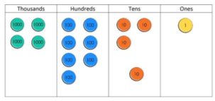
Rounding numbers of up to 4-digits with accuracy  - Round numbers to the nearest 10  - Round numbers to the nearest 100  - Round numbers to the nearest 1000  Pupils use number sense to develop a depth of understanding when rounding, estimating the position of the given number to decide which is the nearer multiple of 10, 100 or 1000. Make connections to real life contexts to discuss when it’s suitable to round to different degrees of accuracy. | 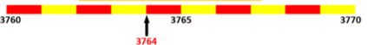
Applying learning
- Use knowledge of place value and rounding to reason with 4-digit numbers

Pupils apply learning from the unit to reason and justify which number from a set is the odd one out. This should involve generating many different possible reasons for each number being the odd one out.

