Year 4 Unit 2: Addition & Subtraction (3weeks)

Key Objectives: | Representations:
Deriving facts from known facts  - Derive addition and subtraction facts  Applying their number sense, pupils use their knowledge of inverse, commutativity and scaling (by 10, 100 and 1000) to derive facts. When deriving calculations from known calculations, make connections to part-whole understanding. Encourage pupils to consider whether the part or whole has changed and the impact this will have on the calculation. | 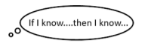  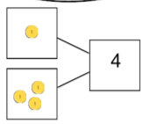
Exploring appropriate strategies  - Choose an appropriate addition strategy  - Choose an appropriate subtraction strategy  Pupils continue to apply their number sense, working flexibly to choose efficient strategies for given calculations. Strategies may include using known facts to derive facts, partitioning, near doubles, round and adjust and finding the difference. Make connections between pupils’ strategies, encouraging them to justify their reasons for choosing a strategy. | 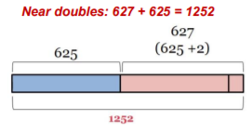  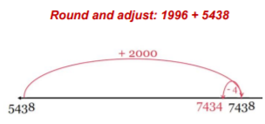
Applying formal column methods  - Use column addition for 4-digit numbers  - Use column subtraction for 4-digit numbers  - Subtracting from multiples of 1000  Pupils use the column method to add and subtract. Pupils initially represent the method using Dienes on a place value chart. As Dienes can be cumbersome with larger numbers, place value counters are then introduced. Throughout this learning, make use of rounding skills when estimating answers beforehand and develop the habit of checking the answer is reasonable. This is key for pupils to see if they’ve made any arithmetic errors when using the column method. Pupils go on to use the column method when subtracting from multiples of 1000 in order to highlight the limitations of this method. In this case, the need for multiple regrouping may lead to arithmetic errors. Use this as an opportunity to make connections to selecting more efficient methods which have been explored in previous lessons. | 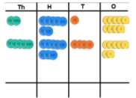  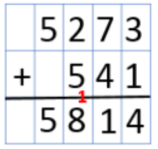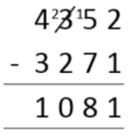
Solving word problems  - Solve one-step problems  - Solve two-step problems  Pupils apply their learning from the entire unit, selecting appropriate strategies to solve additive word problems. First pupils explore ‘partwhole’ structures, then ‘comparison’ structures, before looking at both structures in the context of two-step word problems, drawing bar models to represent the known and unknown values. | 