Year 4 Unit 3: Multiplication and Division (3weeks)

Key Objectives: | Representations:
Deriving multiplication and division facts  - Derive facts to multiply mentally  - Derive facts to divide mentally  Pupils are encouraged to make connections between known facts, drawing on their growing range of mental strategies. Place value counters are used in arrays to support these connections. | 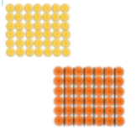
Exploring properties of multiplication  - Calculate multiplication facts using distributive law  - Apply distributive law to multiply 2-digit numbers by 1-digit numbers  - Explore multiplying three 1-digit numbers  Pupils combine multiplication and addition to explore the distributive law. Pupils connect the abstract calculations to various representations to deepen understanding. | 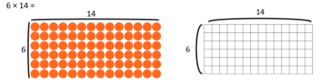
Using and explaining short multiplication  - Short multiplication  - Applying multiplication strategies  Pupils are introduced to the formal written method of short multiplication. Build upon the knowledge of derived facts and the distributive law to help pupils understand what is happening as each step of the procedure is carried out. | 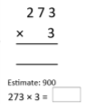
Exploring mental division  - Mental division strategies  - Explore division using known and derived facts  Connections are made between multiplication and division as pupils explore mental strategies for division. Bar models can help to make sense of the problem and use of place value counters represent the number and support grouping for mental division. | 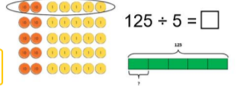
Using and explaining short division  - Short division  Pupils are introduced to the formal written method of short division. Build upon understanding of multiplication to help pupils understand what is happening as each step is carried out. | 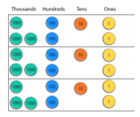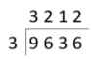
Applying in further contexts
- Apply multiplication and division to problem solving

Pupils should be confident in exploring and making sense of problems (before solving) with the use of bar models to emphasise the structure.

