Year 4 Unit 4: Discrete and continuous data (2weeks)

Key Objectives: | Representations:
Representing data using pictograms  - Read, interpret and compare pictograms  - Construct a pictogram  Pupils make connections with data represented in frequency tables and pictograms, consolidating and extending their understanding of data presented in this way. When constructing and interpreting, attention should be paid to the use of a key and identifying the value of each symbol in the graph. | 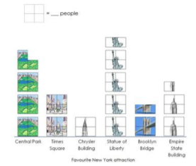
Representing data using bar charts  - Read, interpret and compare bar charts  - Construct a bar chart  Building on understanding of pictograms and their limitations for larger data sets, pupils interpret and compare bar charts. Pupils deepen their understanding of the use of scales for axes and consider the appropriateness of scales and the importance of accurate labelling. | 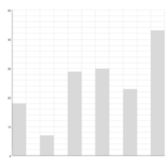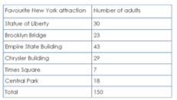
Exploring time graphs  - Read a time graph  - Construct a time graph  - Interpret time graphs  - Construct time graphs with more than one data set  Pupils read and interpret continuous data in the form of time graphs, identifying similarities and differences with other graphs studied in the unit. They use their reading to construct a ‘story of the graph’ and identify possible reasons for the information shown. They consider the appropriateness of scales when constructing time graphs, first with one then two sets of data. When considering two sets of data, pupils learn that presenting data on one graph allows for comparison. | 