Year 4 Unit 5: Securing Multiplication Facts (1week)

Key Objectives: | Representations:
Exploring patterns within and between multiplication tables  - Identify multiplication patterns  - Predict and identify multiplication patterns  Use a variety of models to explore relationships and patterns across multiplication tables pupils know, making connections within and between these multiplication tables. | 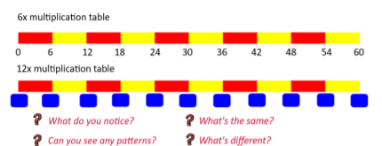  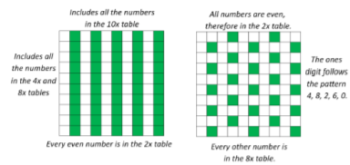  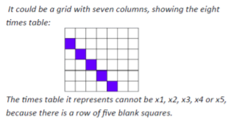
Deepening understanding of multiples of seven and nine  - Multiples of 9  - Multiples of 7  Build upon the models used to focus on the lesser known seven and nine times tables. Encourage pupils to create their own meaningful concrete, pictorial and abstract representations | 