Year 4 Unit 6: Fractions (4weeks)

Key Objectives: | Representations:
Interpreting fractions in different ways (1)  - Recognise different interpretations of fractions  - Identify fractions as part of a set or quantity  - Identify fractions as part of a whole shape  The unit starts exploring different ways of interpreting and bringing meaning to fractions. This is an opportunity to find out current understanding. Lessons explore each interpretation in depth, starting with unit fractions then non unit fractions. Opportunities are taken to explore equivalent fractions as they arise in the models, before they are a focus. | 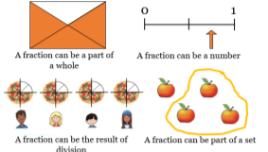
Interpreting fractions in different ways (2)  - Find equivalent fractions  - Identify fractions as ‘the result of division’  - Compare and order fractions  Experiences with equivalent fractions should go beyond teaching ‘multiply the numerator and denominator by the same value’. Focus on identifying relationships between and within fractions, noticing patterns and making connections with multiplication and division. When comparing and ordering fractions, pupils apply their understanding of each interpretation and use a variety of models to develop different strategies for reasoning about the relative size of fractions. | 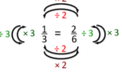  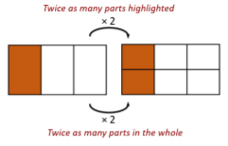
Understanding mixed numbers and improper fractions  - Recognise mixed numbers  - Recognise improper fractions  - Convert mixed numbers to improper fractions  So far, the focus has been on fractions with a value less than 1. Pupils apply their knowledge of interpretations explored so far when representing mixed numbers and improper fractions using a range of models. | 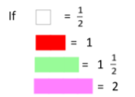
Adding and subtracting fractions with the same denominator  - Add fractions  - Subtract fractions  - Add fractions with an answer greater than one  - Subtract fractions including those greater than one  Pupils extend their learning to calculate using fractions. Experiences with adding and subtracting fractions (with the same denominator) should go beyond teaching the procedure of ‘just add the top numbers’. To deepen conceptual understanding, pupils are exposed to multiple representations, encouraging them to make connections between mixed numbers and improper fractions. | 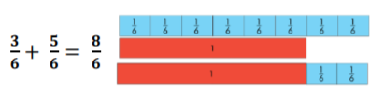
Solving problems involving fractions of a quantity  - Solve problems involving unit fractions  - Solve problems involving non-unit fractions  - Solve multi-step problems by comparing non-unit fractions  Experiences with fractions of quantity should go beyond the procedure of ‘dividing by the denominator and multiplying by the numerator’. Constructing bar models allow pupils to see part-whole relationships and the steps of the procedure. | 