Year 5 Unit 1: Reasoning with larger whole numbers (2weeks)

Key Objectives: | Representations:
Developing understanding of place value with large integers  - Read and write 5-digit numbers and identify place value of each digit  - Read and write 6-digit numbers and identify place value of each digit  Pupils represent 5-digit numbers in a variety of ways including with place value counters and in words. Using Dienes to build and imagine representations of larger integers supports understanding of the magnitude and relationships between these values. They identify the value of each digit and write the sum of its place value parts. Pupils will extend their understanding of the number system and place value to 6-digit whole numbers, finding 1, 10, 100, 1000 and 10 000 more or less. | 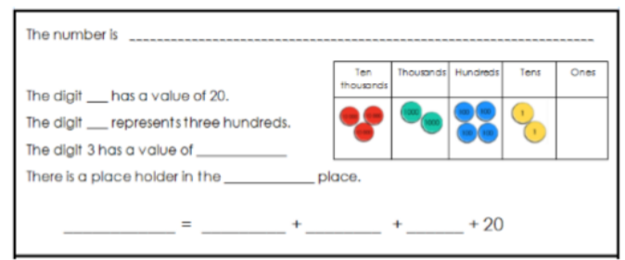
Comparing and ordering 5- and 6-digit numbers  - Order numbers with up to 5-digits within a given context  - Compare and order 5-digit numbers  - Order up to 6-digit numbers within a context  - Compare and order 6-digit numbers  Pupils generate 5- and 6-digit numbers before comparing and ordering. Number lines are used to position numbers and identify other values based on their relative position, developing pupils’ number sense. | 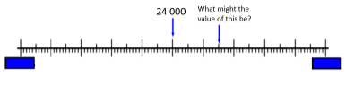
Rounding larger numbers including when in context  - Round 5-digit numbers to the nearest 100, 1000 or 10 000  - Round 6-digit numbers to the nearest 1000, 10 000 or 100 000  - Apply rounding skills  Pupils round 5-digit numbers by identifying the multiples either side, applying this in context. Pupils continue to develop their understanding of rounding by extending this to 6-digit numbers. A deeper understanding of rounding is developed through exploration of numbers which round to the same multiples of a power of ten. Opportunities are provided for pupils to solve problems involving rounding. | 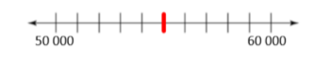
Solving problems with a range of strategies  - Read Roman numerals and compare this system to our own number system  The Roman numerals system is similar to our number system in some ways and different in others. It is not a base ten system and dedicating time to comparing this structure can deepen understanding of our base ten system. Pupils are challenged to create concrete representations that can be used to represent Roman numerals in order to calculate. | 