Year 5 Unit 2: Integer addition & subtraction (2weeks)

Key Objectives: | Representations:
Using what you already know  - Use and explain addition and subtraction strategies  - Add and subtract multiples of 10, 100, 1000, 10 000 and 100 000  The unit starts by exploring calculation strategies for addition and subtraction of 2-digit and 3-digit numbers. This is an opportunity to review strategies from previous years with a strong focus on clearly explaining, using equipment, sketches and jottings, to demonstrate the understanding. There is a focus on using known facts to calculate with large numbers, supporting pupils to realise how much they can do with number bonds to 20, and highlighting the importance of being fluent in the recall of these facts. | 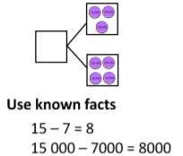  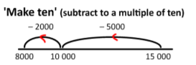
Exploring strategies  - Add and subtract using a round and adjust strategy  - Use a range of partitioning strategies to add and subtract  - Use rounding to estimate calculations  The purpose of these lessons is to review calculation strategies that pupils know from previous years and extend these for use with larger integers. A variety of manipulatives and models are suggested to visualise the structure of these strategies to support understanding and accuracy. Lessons make clear links to the previous unit and provides an important purpose for rounding in order to estimate and check accuracy of calculation. | 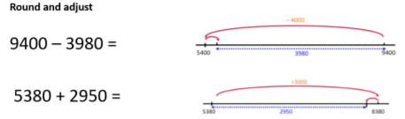
Using written methods  - Use column addition to calculate with large whole numbers  - Use column subtraction to calculate with large whole numbers  - Use column methods  Formal written method of addition and subtraction are the focus of the next sequence of lessons. Pupils have used these methods in Year 4 and now extend to work with 5-digit and 6-digit numbers as well as adding more than two numbers. Place value counters are used alongside the written method as a tool for explaining how the procedure works and focusing attention on what is happening as each step is carried out. Support pupils to develop the habit of deciding when to use a written method and when a different method may be more efficient. | 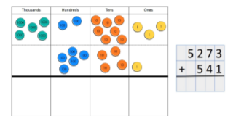
Solving multi-step problems  - Use a range of mental strategies while problem solving  Lessons provide a context for pupils to complete lots of calculations. This is an opportunity to bring together the experiences so far in the year to solve multi-step problems. A variety of calculation strategies should be encouraged. | 