Year 5 Unit 3: Line graphs & timetables (2weeks)

Key Objectives: | Representations:
Interpreting line graphs  - Tell the story of a line graph  - Interpret, read and solve problems with line graphs  - Interpret and read line graphs and tables  Pupils begin by exploring a range of line graphs without values on the axes in order to focus on telling the story of the data, thinking about the shape of the line. Scales are introduced in lesson two with a focus on accurately reading the graph. This is built upon to explore how the representation changes when you change the scale. Throughout these lessons pupils apply and consolidate skills including working with larger integers, strategies for addition and subtraction and estimation skills. | 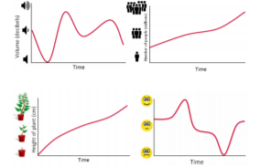
Constructing a line graph  - Present information as a line graph  Pupils make connections to discussions held in the previous lesson (around how the chosen scale used on the axes could change the way the data looks) to make informed design choices for their own line graph. Pupils accurately plot the data onto the line graph and are then given a second set of data. Highlight that by placing multiple data sets onto one graph they are able to compare and contrast more efficiently. | 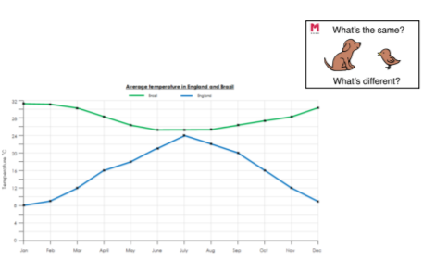
Interpreting conversion graphs  - Read and interpret conversion graphs  Pupils explore conversions graphs, which represent a relationship between measures e.g. miles and kilometres. They apply existing skills of interpreting and reading graphs to read a variety conversion graphs. They then apply this understanding to construct their own conversion graph. | 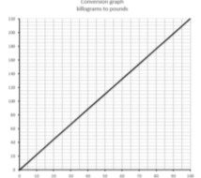
Reading timetables  - Read and interpret timetables  Timetables come in a variety of formats and involve a range of different conventions. Pupils should be exposed to timetables in different orientations and layouts. Connections should be made to situations where pupils use timetables outside of the classroom and it may be worth asking pupils to bring in examples/photos of timetables that they have used. Pupils will spend time reading and interpreting timetables and solve problems relating to the timetables that involve calculating intervals of time. | 