Year 5 Unit 4: Multiplication & Division (3weeks)

Key Objectives: | Representations:
Understanding multiples, factors & squares  - Identify multiples and factors  - Find all factor pairs of a number  - Solve problems using factors, multiples and square numbers  - Establish if a number less than 100 is prime  This sequence of lessons explores the properties of numbers. Teaching should focus on comparing and contrasting the features of factors, multiples, square and prime numbers. This should lead to pattern seeking and pupils developing deeper understanding of these key properties of number | 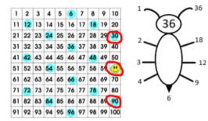
Exploring mental strategies for multiplication & division  - Multiply and divide by 10, 100 and 1000  - Multiply and divide mentally using doubling and halving  - Multiply and divide using derived facts  Within these lessons, pupils should be exposed to a range of strategies to support increasingly efficient mental multiplication and division. Encourage pupils to compare and contrast their ideas to identify similarities and differences and encourage them to consider the most appropriate strategy for them. | 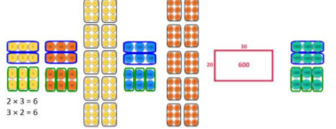
Exploring and selecting appropriate strategies  - Solve problems using a range of strategies  Pupils to explore applying strategies from previous lessons in an unfamiliar context. The focus is on justifying the efficiency of the strategy. | 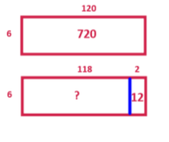
Using and explaining multiplication methods  - Use a written method to multiply  - Multiply two 2-digit numbers using long multiplication  - Multiply using knowledge of factors  As well as encountering and practising formal written methods, pupils should explore how to represent problems and continue to develop flexibility when selecting strategies. | 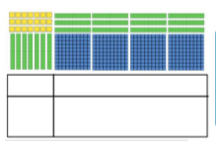
Using and explaining division methods  - Use knowledge of multiples to divide  - Use a written method to divide  - Solve problems involving division with remainders  As with lessons on multiplication, pupils should represent and solve problems choosing from a range of strategies, resorting to the written method only when it is the most efficient strategy for them. Pupils may draw or visualise bar models to make sense of the problem and should be encouraged to estimate mentally. | 