Year 5 Unit 5: Perimeter and Area (1week)

Key Objectives: | Representations:
Calculating perimeter  - Calculate and measure perimeter  Pupils review what perimeter is and find the perimeter of 2-D shapes, before moving on to composite rectilinear shapes. As there are different ways to calculate the perimeter of the same shape, pupils should explore and make connections between these. This provides an opportunity to consolidate mental calculation strategies. | 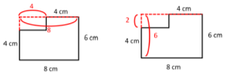
Calculating area of composite rectilinear shapes  - Calculate the area of rectangles  - Calculate the area of rectilinear shapes  Pupils build on the work from Year 4 where area was introduced as a measure of surface and connected to multiplication and arrays. Encourage pupils to generalise this relationship and express that area = length x breadth. Building on this, pupils compare and contrast different strategies for calculating the area of composite rectilinear shapes. This includes partitioning the shape in different ways and finding the area of a larger rectangle and subtracting the missing section. | 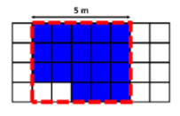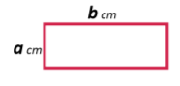
Investigating the relationship between area and perimeter
- Compare the area and perimeter of rectangles

Investigating the relationship between the value of the perimeter and area is interesting as pupils may feel that these should be related, but generally there is no direct relationship which may be something of a surprise. Pupils are encouraged to test out conjectures, look for patterns and find ways to work systematically. In this lesson, pupils are challenged to express the perimeter and area of a rectangle using algebraic notation.
Calculating area of non-rectilinear shapes  - Calculate the area of non-rectilinear shapes  Provide pupils with opportunities to imagine and visualise rectangles within non rectilinear shapes (e.g. a triangle). Pupils record the area of these rectangles and then count the remaining whole squares and then half squares in the shapes. Afterwards, pupils work with more challenging shapes with curved sides which involve more complex decisions when deciding on an estimate. | 