Year 5 Unit 7: Angles (2weeks)

Key Objectives: | Representations:
Developing understanding of angles  - Classify, compare and order angles  Pupils use an angle maker to review their understanding of angles as a measure of turn. They identify acute, right and obtuse angles and are introduced to reflex angles, identifying these in shapes. | 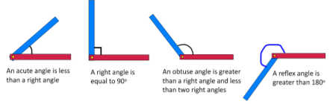
Using a protractor  - Measure angles using a protractor  - Draw angles using a protractor  - Measure and draw reflex angles  Pupils use a protractor to measure acute and obtuse angles and explore how to use the different scales on the protractor to measure the same angle. Pupils then move onto sketching angles using a ruler before measuring them with a protractor to see how accurate they were. The same skills are then applied to reflex angles. | 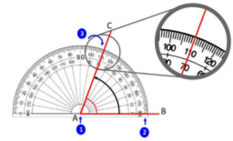
Exploring angle facts
- Know that angles at a point are equal to 360°
- Identify angles at a point on a straight line total 180°

Pupils build understanding that a full turn is equal to 360 degrees and use hands on a clock to explore two angles that sum to 360°. They then use this knowledge to measure reflex angles. Pupils move on to review their understanding that a half turn and the angle of a straight line are 180° and use this knowledge to measure and calculate missing angles at a point on a straight line.
Investigating angles  - Investigate angles at a point within shapes.  - Investigate angles within shapes  Pupils explore angles made by patterns of crossing lines and try to see how many angles they can calculate rather than measure using knowledge about angles at a point. They then draw triangles and begin to explore the angles within a triangle. Pupils move on to investigate a series of statements about the angles within shapes, justifying whether they are always, sometimes or never true, using geoboards and grid paper to support their choices | 