Year 6 Unit 1: Integers and Decimals (2weeks)

Key Objectives: | Representations:
Understanding 7-digit numbers  - Read and write 7-digit numbers  - Order and compare numbers with up to 7 digits  Pupils begin the unit by developing understanding of integers up to 10 million. Opportunities should be taken for pupils to visualise the relative magnitude of 1 million in different ways e.g. Dienes equipment, use of books such as ‘How much is a million?’. Pupils learn how to read, write and say large integers and this should be revisited regularly. A key concept for this lesson is the use of place holders. Representing numbers to ten million is applied in lesson 2 where pupils compare and order integers using place value understanding. | 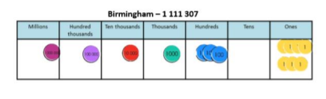
Applying rounding skills  - Round integers to required degree of accuracy  - Apply rounding to estimate  Pupils should be familiar with strategies for rounding integers to the nearest multiple of different powers of 10 and they extend this to rounding 7-digit numbers, including to the nearest multiple of 100,000. Pupils apply their understanding of rounding to estimate, considering different degrees of accuracy to support estimation. Throughout both lessons, the use of number lines is encouraged to ensure pupils develop a conceptual understanding of the procedure. | 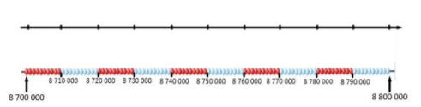
Applying addition and subtraction strategies  - Explore strategies for addition  - Explore strategies for subtraction  - Apply strategies to problems involving decimals  - Apply strategies to multi-step problems  Pupils consolidate their understanding of different strategies for addition and subtraction, with a focus on mental strategies. Empty number lines are a key representation throughout these lessons to allow pupils to represent and articulate their strategy. Pupils often resort to column methods without considering efficiency e.g. recognising when a ‘count on’ to find the difference strategy is quicker than column subtraction. Opportunities to model and use different strategies should be provided throughout, these strategies are applied to working with decimal values including multi-step problems involving adding more than two values. Later lessons involve different multi-step problems, including ‘I’m thinking of a number’, to provide opportunities for pupils to consolidate the strategies developed and consider whether the problem requires addition or subtraction. Throughout these lessons, pupils should be encouraged to apply their rounding skills to estimate and check if the response is reasonable. | 