Year 6 Unit 2: Multiplication and Division (3weeks)

Key Objectives: | Representations:
Exploring decimal place value  - Understand decimal place value to 3 decimal places  Pupils extend their understanding of decimal place value to three decimal places with consolidation and development of thousandths. Take time to explore the relative magnitude of this unit compared to others. In this lesson, Dienes equipment is repurposed to represent decimal numbers, supporting pupils’ understanding of place value | 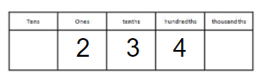
Multiplying and dividing by powers of 10
- Multiply and divide by powers of 10

Pupils consolidate and extend their understanding of multiplication and division by powers of 10. Consider how misconceptions relating to adding and removing zero can be planned for and how modelling can support conceptual understanding. Pupils apply their knowledge of multiplying and dividing by 10, 100 and 1000 in context using metric units of measure.
Knowing number properties  - Identify common factors and multiples  - Identify prime numbers  Pupils may have some familiarity with properties of number from previous years and so these lessons should be adapted to suit the needs of pupils. In lesson 3, multiple representations are used to show factors and the concept of common factors is introduced and explored with an emphasis on verbal explanation. Factor bugs are a particularly useful representation to systematically find all factors. This knowledge is applied to identify prime numbers and pupils apply understanding through playing a game. Take time to explore and discuss the number one, which is not a prime number. | 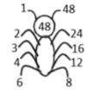
Applying multiplication strategies  - Solve problems using known and derived facts  - Use the formal short multiplication method  - Use the formal long multiplication method  Throughout these lessons, pupils should be encouraged to apply estimation strategies developed earlier in the year to check the reasonableness of their answer. Pupils should also represent problems pictorially to show the relationship between known and unknown values, such as by using bar models. Pupils consolidate mental strategies for multiplication using known facts in the context of currency conversions. Pupils then develop the use of the short formal method for multiplication, including decimals. Pupils should be able to articulate each step of this process using correct place value language to deepen conceptual understanding and modelling should make use of representations to make the steps of the procedure clear. Then the formal long multiplication method is introduced including 4-digit by 2-digit multiplication and multiplying decimal numbers. Pupils should draw on their understanding of multiplying by powers of 10 to support their calculation. | 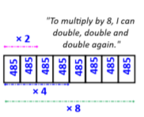  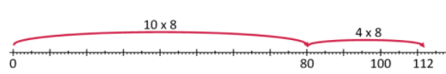  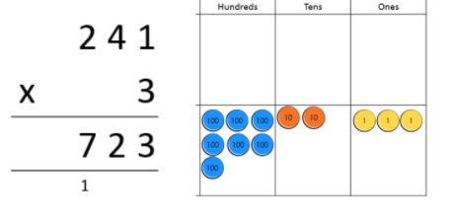
Applying division strategies  - Explore efficient division strategies  - Use the formal short division method  - Use the formal long division method  - Interpret remainders  Pupils deepen their understanding of strategies for division. As with other operations, many pupils select a formal written method automatically and so time should be taken in lesson 10 to explore other strategies and encourage pupils to consider the numbers in each problem to select an efficient strategy. In this lesson, doubling and halving strategies are developed along with using known facts to derive other division facts. Lesson 11 and 12 introduce using the formal written short and long division methods for 3- and 4-digit numbers divided by 1- and 2-digit divisors. As with multiplication methods, take time to clearly model and articulate each step with reference to place value to deepen conceptual understanding of the procedure. In lesson 13 pupils explore remainders, considering problems where the context defines how the remainder is interpreted when answering. | 