Year 6 Unit 3: Calculation Problems (2weeks)

Key Objectives: | Representations:
Understanding the agreed order of operations  - Understand which operations have equal priority.  - Understand the order of operations including brackets  - Use and apply the order of operations  Pupils learn the agreed order of operations, including the use of brackets, through exploration of different problems. Pupils solve multi-step problems involving addition and subtraction or multiplication and division in different ways to identify that order does not matter and these operations have equal priority. Representations such as cubes can practically demonstrate this, and pupils are encouraged to consider efficiency when doing so e.g. identifying and summing number bonds. Pupils learn that multiplication and division have priority over addition and subtraction through exploring a range of possible answers to one multi-step calculation. They then understand how brackets are used to alter the order of a calculation and the priority these have. Then there are opportunities to apply understanding of the order of operations in different contexts including area and perimeter. | 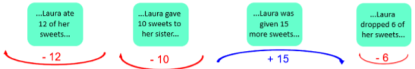  BODMAS/ BIDMAS
Exploring problems with unknown values  - Generate and describe linear number sequences  - Express missing numbers algebraically  - Create algebraic expressions for different contexts  Revisit and consolidate different numbers including decimals and negative numbers as they generate, explore and compare a range of linear number sequences. By considering numbers that will and will not appear in given sequences pupils are challenged to reason and explain. Introducing algebraic notation. Take time to connect this notation to familiar representations of unknown values such as empty box problems and bar models. Through familiar contexts such as the perimeter and area of rectangles, pupils make sense of expressing missing numbers algebraically, and lessons provide opportunities to write algebraic expressions for further contexts | 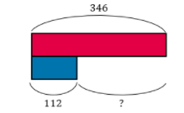
Solving problems with unknown values  - Satisfy equations with two unknowns  - Apply problem solving strategies  Pupils apply their understanding of algebraic notation to problems with more than one unknown, providing opportunities to ‘enumerate possibilities’, that is, identify that these problems may have more than one correct answer. Again, connections should be made between different representations of unknown values and the focus should be on discussion and reasoning. Lessons then consist of a range of non-standard problem contexts and are an opportunity to consolidate learning from this and previous units. | 