Year 6 Unit 4: Fractions (2weeks)

Key Objectives: | Representations:
Developing fraction understanding  - Identify, describe and represent fractions  - Understand and describe fraction equivalence  - Find equivalent fractions in their simplest form  Pupils begin the unit exploring what a fraction is through different representations, and you may wish to use this as an assessment opportunity. Through multiple representations, including Cuisenaire, pupils identify and describe different fractions including improper fractions. Pupils find and describe equivalent fractions, first exploring any equivalent fractions and then considering a fraction’s simplest form. With the support of a range of representations, they will describe equivalence through a) identifying an equivalent multiplicative relationship between numerators and between their respective denominators and b) identifying an equivalent multiplicative relationship between the numerator and denominator within each fraction | 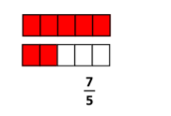  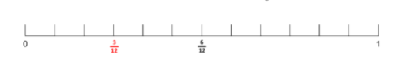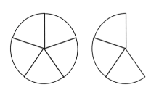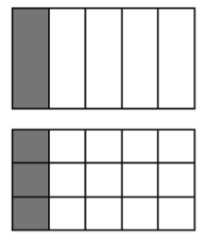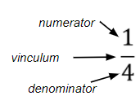
Comparing and ordering fractions  - Compare and order fractions  Pupils employ a range of representations and strategies to compare and order fractions in a variety of contexts. They begin with proper fractions considering which is greater before the introduction of comparing mixed numbers and improper fractions. Lessons are opportunities to develop number sense and a sense of the size of fractions through comparison to simple fractions such as a half. Earlier skills including equivalence and simplifying are used. | 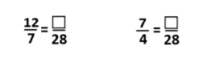
Understanding fraction and decimal equivalence  - Recall and use fraction and decimal equivalence  - Calculate decimal equivalence using short division  Pupils begin by consolidating their understanding of equivalence of one half and 0.5 before extending this to consider further decimal equivalence. Pupils should apply their understanding of equivalent fractions and opportunities should be taken to connect this with decimal tenths and hundredths. Lessons deepen the understanding of fractions as an operator through revisiting short division strategies to find equivalence, including fractions such as one third. There are lots of opportunities to promote number sense across these lessons and encouraging flexibility in thinking about decimals and fractions in different ways supports pupils when working with both. | 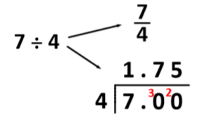
Adding and subtracting fractions
- Add and subtract fractions with different denominators

Pupils have experienced addition and subtraction of fractions with the same denominator or where one denominator is a multiple of the other in previous years. Take time to connect the new learning within these lessons to previous models and structures. Pupils should apply their skills of equivalence and will solve problems with addition and subtraction in different contexts. Pupils solve problems including mixed numbers and improper fractions, including number sequences.

