Year 6 Unit 5: Missing angles and lengths (1week)

Key Objectives: | Representations:
Developing angle facts  - Recognise angle properties in different formats  Pupils learn different angle facts: angles about a point sum to 360, angles on a straight line sum to 180 and angles that are vertically opposite are equal. Opportunities for pupils to explore and reason should be provided, and these facts can be applied to learning throughout the unit. The Independent Task involves pupils using tape to create different angles for them to then investigate. Throughout the lesson pupils should be encouraged to express relationships using bar models and algebraic notation. | 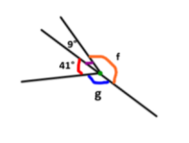
Exploring triangles and quadrilaterals  - Compare and classify triangles  - Compare and classify quadrilaterals  Through comparing and classifying, pupils consolidate their understanding of the critical features of different types of triangles and quadrilaterals, with a focus on similarities and differences. You may wish to use the beginning of each lesson to assess understanding of these polygons, addressing misconceptions before moving on. In lessons, the Develop Learning focuses on the property of the internal angles of quadrilaterals, including exploration of diagonals within these shapes. | 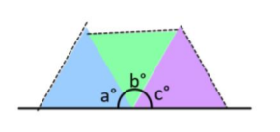  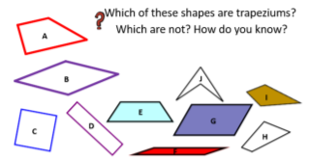
Finding missing angles  - Find missing angles and lengths  - Calculate missing angles in polygons  Pupils draw on their understanding of properties of angle and shape to calculate missing angles and lengths in a variety of ways They represent problems using bar models, drawing on their understanding of algebraic notation from earlier in the year. Lessons provide an opportunity for pupils to apply their knowledge of internal angles of triangles and quadrilaterals. Lessons introduce internal angles of other regular polygons through the understanding of angles within triangles. It is not expected that pupils will generalise about the relationship between sides of polygon and sum of internal angles, however this may be a point for pattern seeking and discussion. Lessons provide opportunities to consolidate addition and subtraction strategies in a different context. | 