Year 6 Unit 6: Coordinates and Shape (2weeks)

Key Objectives: | Representations:
Drawing 2-D shapes  - Draw 2-D shapes  Pupils begin the unit by drawing 2-D shapes using given instructions, consolidating their understanding of the properties of shapes as well as the skill of using a ruler and protractor accurately. Take time to ensure these skills are secure and consider how you will clearly model the use of this equipment. | 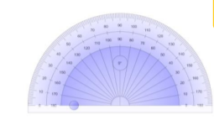
Using and applying coordinates  - Describe coordinates in all four quadrants  - Draw and translate 2-D shapes  - Draw and reflect 2-D shapes  - Solve problems involving coordinates  Pupils consolidate their understanding of describing and plotting coordinates before extending this to consider a full coordinate grid. Consider how this lesson can be used to explore key difficulty points including the order coordinates appear in and the coordinates of points on the axes. Pupils should be able to generalise about the values of coordinates in each quadrant. Pupils have experienced translation and reflection of 2-D shapes in previous learning and this is extended in lessons by translating and reflecting across the axes. Opportunities to pattern seek and identify the relationships between coordinates before and after reflection and translation should be taken, with pupils beginning to visualise and calculate the new coordinates as a result of the transformation. In further lessons pupils apply their deepening understanding of 2-D shapes on a coordinates plane to finding missing points first with, and then without gridlines. They draw on their understanding of the properties of 2-D shapes to calculate and plot missing points | 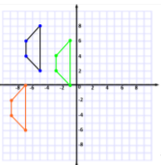  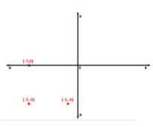
Exploring 3-D shape  - Describe 3-D shapes including from nets  - Recognise and build 3-D shapes from nets  Pupils compare and classify a range of 3-D shapes, applying their understanding of the properties of 2-D shapes. This allows opportunities to generalise about the properties of categories of 3-D shapes such as prisms. Throughout this lesson pupils should be exposed to a range of concrete and pictorial 3-D shapes. They then explore nets and discuss the 2-D shapes required to build a net, before solving problems involving nets, such as the position of dots on the net of a die. Alongside encouraging pupils to visualise folding nets, pupils should have opportunities to practically experience this. | 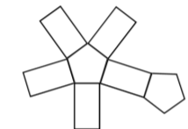  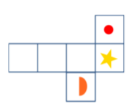
Describing circles  - Illustrate and name parts of a circle  Pupils learn the names of different parts of the circle and this knowledge should be regularly revisited in Maths Meetings. Ensure exposure to examples and non-examples of key parts such as the radius and diameter to deepen understanding. Pupils then solve problems involving the relationship between radius and diameter. | 