Year 6 Unit 7: Fractions(2) (1week)

Key Objectives: | Representations:
Multiplying fractions  - Multiply an integer by a proper fraction  - Multiply two fractions  - Solve problems involving multiplying fractions  Pupils draw on their earlier experiences and understanding of fractions, including representations, to calculate with fractions. In lessons pupils develop strategies for multiplying integer values by proper fractions, drawing on their understanding of commutativity and developing conceptual understanding through representations including bar and area models. Pupils explore representations to deepen conceptual understanding of multiplication of one fraction by another. Pupils apply this understanding to worded problems in different contexts. | 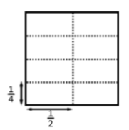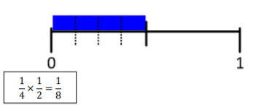
Dividing fractions  - Divide a fraction by an integer  Pupils develop their understanding of the process of dividing a fraction by an integer  through representations, making connections with multiplication and recognising that, for  example, dividing by three is the same as multiplying by one third, or finding one third of  an amount. Within the lesson, pupils explore division of fractions where the numerator is  and is not a multiple of the divisor. As with the previous lessons, consider how you will  articulate and model this concept in order to promote a conceptual understanding. | 